Answer:

Code for Homepage:

<html>

<head><title>Web Technology</title>

<style>

.container{

height: 98%;

display: flex;

justify-content: center;

align-items: center;

}

body{

background-color: peachpuff; }

.q{

border: 5px solid #35ff03;

background-color: tomato;

margin: 30px;

padding: 92px 84px;

border-radius: 11px; }

#q1{

text-decoration: none;

color: white;

font-family: cursive;

font-size: 22px; }

#q1:hover{

color: blue;

}

#a:hover{

border: 5px solid #03d0ff; }

</style>

</head>

<body>

<div class="container">

<p class="q" id="a"><a href="Q1.html" id="q1">Calculate Simple Interest</a></p>

<p class="q" id="a"><a href="Q2.html" id="q1">Check if a number is odd or even</a></p>

<p class="q" id="a"><a href="Q3.html" id="q1">Multiplication Table</a></p>

<div>

</body>

</html>

Output:

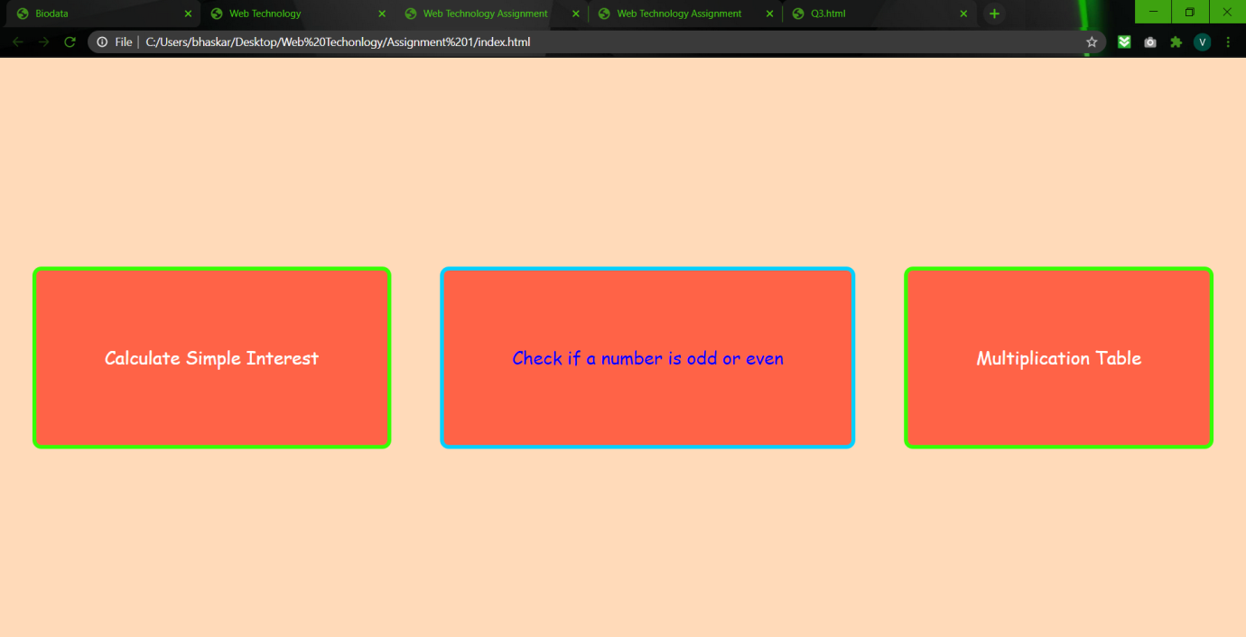

1) Code for simple interest:

<html>

<head><title>Web Technology Assignment</title>

<style>

.content{

display: flex;

flex-direction: column;

justify-content: center;

align-items: center;

height: 450px;

}

body{

background-color: #67bc43;

}

#t1,#t2,#t3{

padding: 8px 0px;

padding-right: 100px;

padding-left: 7px;

border-radius: 5px;

border: 2px solid #9b76a7;

}

button{

padding: 7px 100px;

border-radius: 5px;

border: 2px solid #f3faf4;

background-color: #2ddff1;

color: white;

}

#t1,#t2,#t3,button{

font-family: Andale Mono, monospace;

font-size: 16px;

}

button:hover{

border: 3px solid yellow;

color: tomato;

cursor: pointer;

}

h1{

font-family: Trebuchet MS, sans-serif;

}

#t4{

font-family: Optima, sans-serif;

font-size: 29px;

color: #473fb8;

}

</style>

</head>

<body>

<div class="content">

<h1>Simple Interest Calculator</h1>

<input type="text" id="t1" placeholder="Principal Amount">

<br><br>

<input type="text" id="t2" placeholder="Rate of Interest">

<br><br>

<input type="text" id="t3" placeholder="Year">

<br><br>

<button onClick="si()">Calculate</button>

<p id="t4"></p>

</div>

<script>

function si()

{

var p= parseInt(document.getElementById("t1").value);

var r= parseInt(document.getElementById("t2").value);

var t= parseInt(document.getElementById("t3").value);

var S= parseInt((p\*r\*t)/100);

document.getElementById("t4").innerHTML = "Simple Interest is: "+S;

}

</script>

</body>

</html>

Output:

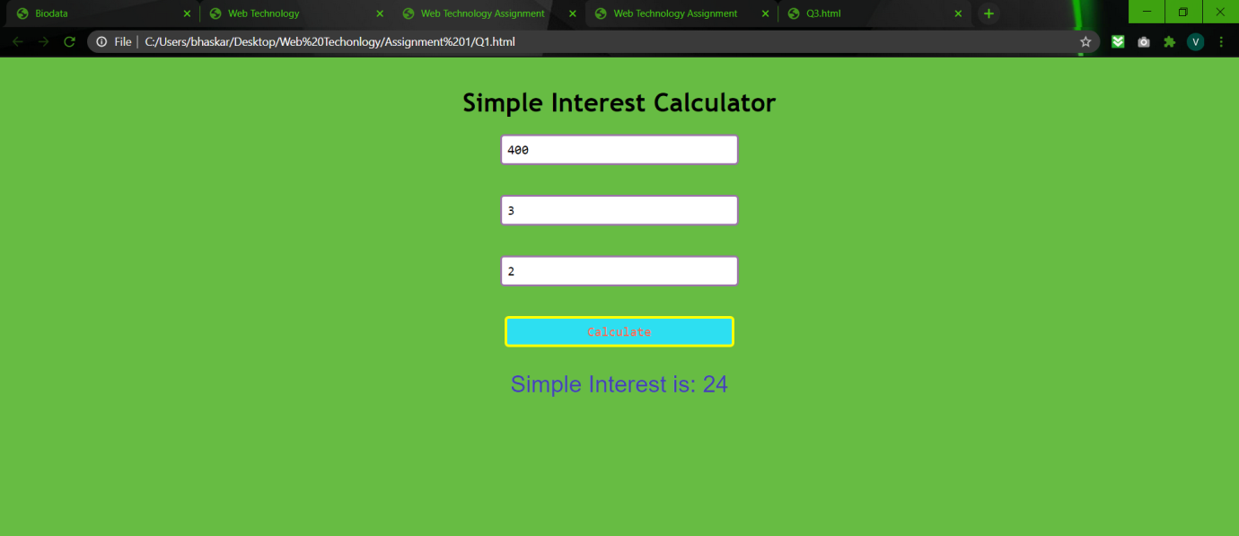

2) Code for odd-even number identifier:

<html>

<head><title>Web Technology Assignment</title>

<style>

.division{

display: flex;

flex-direction: column;

height: 400px;

justify-content: center;

align-items: center;

}

#t1{

padding: 8px 0px;

padding-right: 100px;

padding-left: 7px;

border-radius: 5px;

border: 2px solid #9b76a7;

}

button{

margin-top: 30px;

padding: 7px 129px;

background-color: #ce9bdf;

border-radius: 5px;

border: 3px solid #fcff47;

}

body{

background-color: #b2e58b;

}

#t1,button{

font-family: Andale Mono, monospace;

font-size: 17px;

}

h1{

font-family: Trebuchet MS, sans-serif;

}

button:hover{

color: blue;

border: 3px solid red;

cursor: pointer;

}

#t2{

font-family: Optima, sans-serif;

font-size: 29px;

color: #473fb8;

}

</style>

</head>

<body>

<div class="division">

<h1>Odd-even number identifier</h1>

<input type="text" id="t1" placeholder="Enter a number">

<button onClick="func1()">Check</button>

<p id="t2"></p>

</div>

<script>

function func1()

{

var a = parseInt(document.getElementById("t1").value);

if(a%2==0)

{ document.getElementById("t2").innerHTML=""+a +" is an even Number";

}

else

document.getElementById("t2").innerHTML=""+a +" is a odd Number";

}

</script>

</body>

</html>

Output:

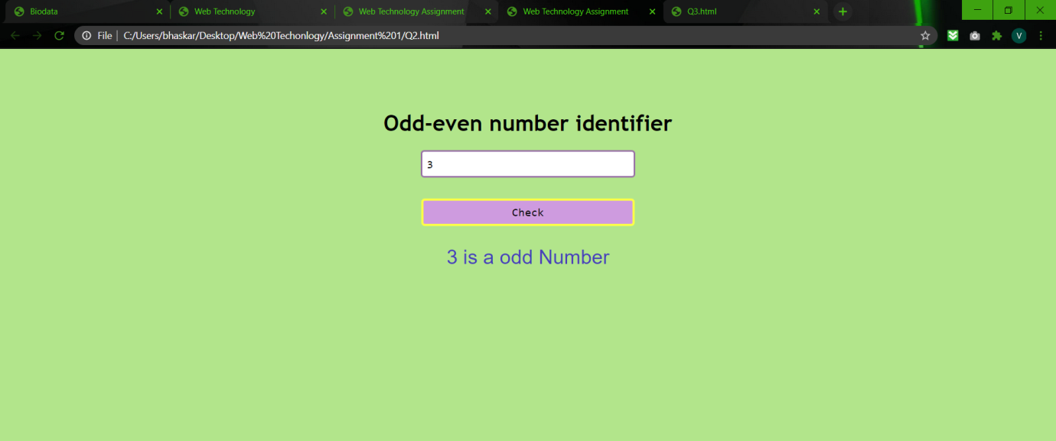

3) Code for multiplication table:

<html>

<head><title>Web Technology Assignment</title>

<style>

.content{

display: flex;

height: 400px;

justify-content: center;

align-items: center;

}

#t1,#t3{

padding: 7px 0px;

padding-right: 100px;

padding-left: 7px;

border-radius: 5px;

border: 2px solid #9b76a7;

}

button{

padding: 5px 111px;

background-color: #cc8282;

border-radius: 5px;

border: 3px solid #2cdfb6;

}

body{

background-color: #e0a6e1;

}

#t1,#t3,button{

font-family: Andale Mono, monospace;

font-size: 17px;

}

h1{

font-family: Trebuchet MS, sans-serif;

}

button:hover{

color: #6803ed;

cursor: pointer;

}

#t2,#t4{

font-family: Optima, sans-serif;

font-size: 29px;

color: #473fb8;

}

#div1,#div2{

margin: 123px;

}

#div1,#div2{

border: 3px solid #558f95;

padding: 31px 35px;

background-color: #dbfad7b3;

border-radius: 8px;

}

h2,h1{

text-align: center;

}

h1{

padding-top: 38px;

}

</style>

</head>

<body>

<h1>Multiplication Table</h1>

<div class="content">

<div id="div1">

<h2>For Loop</h2>

<input type="text" id="t1" placeholder="Enter Table Number">

<br><br>

<button onClick="tab()">Calculate</button>

</div>

<div id="div2">

<h2>While Loop</h2>

<input type="text" id="t3" placeholder="Enter Table Number">

<br><br>

<button onClick="tab1()">Calculate</button>

</div>

</div>

<script>

function tab()

{

var a= parseInt(document.getElementById("t1").value);

for(let i=1;i<=10;i++)

{

var b = parseInt(a\*i);

document.write(""+a +"&nbsp"+ "X"+ "&nbsp"+ ""+i +"&nbsp"+ "="+ "&nbsp"+ ""+b);

document.write("<br>");

}

}

function tab1()

{

var d= parseInt(document.getElementById("t3").value);

let v=1;

while(v<=10)

{

var c = parseInt(d\*v);

document.write(""+d +"&nbsp"+ "X"+ "&nbsp"+ ""+v +"&nbsp"+ "="+ "&nbsp"+ ""+c);

document.write("<br>");

v++;

}

}

</script>

</body>

</html>

Output:

For Loop:

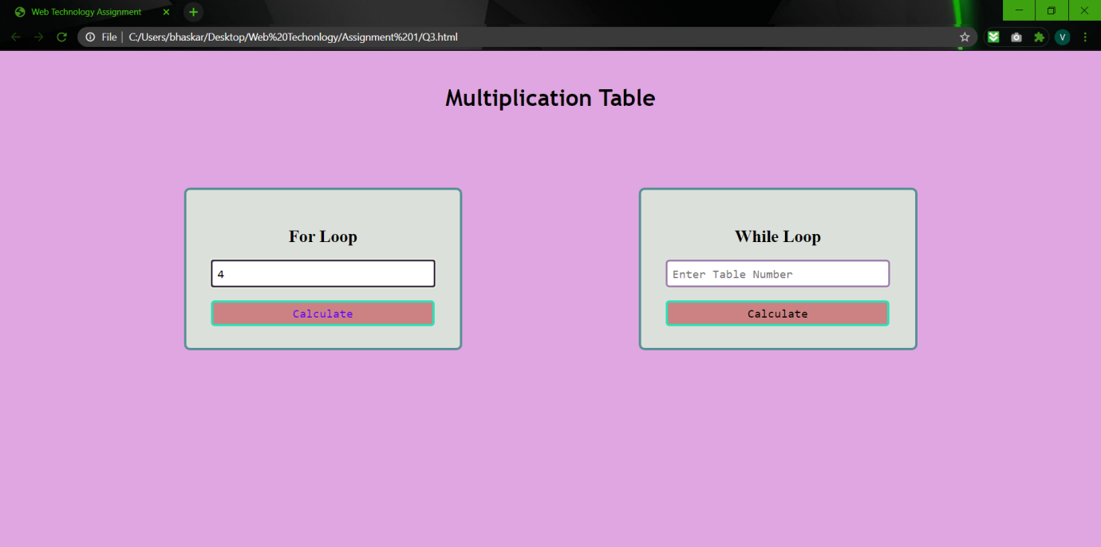

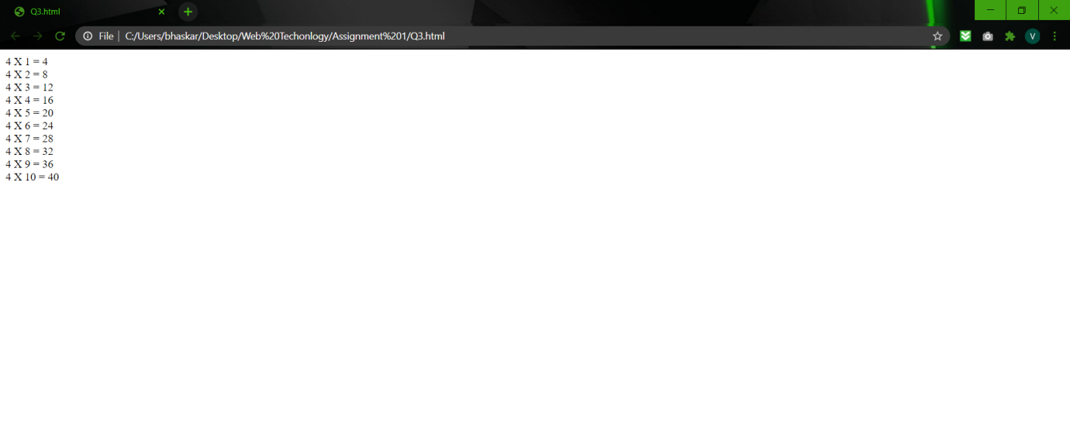

While Loop:

